TEMA METROPOLITAN ASSEMBLY
DEPARTMENT OF SOCIAL WELFARE AND COMMUNITY DEVELOPMENT
FIRST QUARTER 2021 PROGRESS REPORT
- INTRODUCTION
The Department of Social Welfare and Community Development works in partnership with people in their communities to enhance their wellbeing through promoting development with equity for the disadvantaged, vulnerable and excluded groups and individual. In addition, the Department assists to organize community development programs to improve and enrich rural life. There are two (2) units that make up the Department, that is Social Welfare and Community Development units.

The following activities were undertaken during the first quarter;

- PROGRAMME DELIVERY (SOCIAL WELFARE UNIT)
7 Key/Top  Commitments | Results/Achievements | Relation to GSGDA I  Component | Relation to Presidents  Priority for 2020
1. Number of households on LEAP  2. Payment to LEAP households during the quarter  3. LEAP households on NHIS to access health care. | 489 households on LEAP to access cash transfers; 108 male caregivers and 381 female caregivers.  Caregivers received the 69th and 70th LEAP payment cycles.  GHS 548.45 received as operations and mobilization funds.  500 LEAP beneficiaries on NHIS. | Social Development | 4.3.12  Social Development
- 1. Identification and registration of PWDs | 45 PWDs applied to access DACF for PWDs | Social Development | 4.3.13 Disability and Development
6. Registration, renewal, supervision and activities of Non-Governmental Organizations to ensure they operate according to laid down standards in order to enhance service delivery | Two (2) NGOs certificates renewed  Three (3) NGOs are pending registration | Social Development | 4.3.5 Poverty and Inequality
7. Registration and supervision of Early Childhood Development Centres to ensure they operate with the laid down standards. | Twenty-seven (27) early childhood development centres were supervised.  Fourteen (14) day care centres submitted their documents and certificates for renewal. Nine (9) schools do not meet the standard of operations of the Department and they are recommended for close down | Social Development | 4.3.7 Child and Family Welfare
8. Psychosocial support to clients and their families | 87 clients counselled on varied issues. | Social Development | 4.3.7 Child and Family Welfare
9. Serve as panel members at the T.D.C. and White House Family Tribunal Courts | Magistrates were assisted to make informed decisions on fifty-four (54) cases on the welfare of children. The number of children involved are thirty-five (35)-14 females and 21 males. | Social Development | 4.3.7 Child and Family Welfare
10.Mediate in child maintenance, custody/access and family reconciliation cases in the best interest of children involved | 70 cases were amicably resolved | Social Development | 4.3.7 Child and Family Welfare

PROGRAM DELIVERY: COMMUNITY DEV.T UNIT
10 Key/Top  Commitments | Results/Achievements | Relation to GSGDA I  Component | Relation to Presidents  Priority for 2015
Educate the general public, especially women on issues pertaining to government policies and social life through study group meetings, mass meetings, home visits and community ooutreach pprograms.  Assist women in income generating ventures to improve the credit-worthiness of their businesses for micro-credit support.  Collaboration with stakeholders | During the quarter in review, the unit reached out to 8 community-based organizations and women groups and conducted a total of 32 study group meetings. Topics discussed include ccorona virus, Child protection, abuse management, ssexual and gender-based violence. A total of 13 males and 198 females were educateded.  21 homes visits were carried out throughout the quarter with discussions on sanitation, child protection, corona virus, abuse management, Sexual and gender-based violence. In all, 85 households were visited. A total of 9 males and 87 females were reached.  Eight (8) people, 4 male and 4 females were equipped with income generating skills during the period. They were trained in powdered detergents, liquid soap, and bleach making.  The Unit in collaboration with UNICEF Ghana and Ghana Health Service organized four community-based sensitization drives to engage participants on child protection, sexual and gender-based violence issues in their communities. The selected communities were Zinginshore, Awudum, U-Compound and Manhean, in Tema East Sub Metro. A total of 323 participants were reached, of which 33 were males and 290 were females.  The unit embarked on monitoring to residential home and training on case management standard operating procedures in four residential homes in collaboration with the Social Welfare Unit. This was to ensure standardisation of their operations. The four residential homes are Remar Christian Rehabilitation Center, Power of Love Foundation, Save Them Young Orphanage and SOS Children’s Village, Tema.  The Unit collaborated with SOS Ghana Family Strengthening Program in Manhean and the Bornwin foundation to celebrate this year’s International Women;s Day. The Global theme was Choose to Challenge at Peniel Charismatic Ministry International in Awudum. The keynote speaker, Chief Inspector Sabina Ama Blay of DOVVSU. The topic she spoke on was child protection, sexual and gender-based violence. She reiterated the concerns of her outfit with regards to community shielding perpetrators of various domestic infringements and urged the participants to choose to challenge the status quo in their societies and rise above the stereotypes.  Two industrious entrepreneurs in the Tema East area added their voices to the call for women standing for their independence and liberation regardless of their social status and finding extra income steams to empower themselves. | CHAPTER SEVEN: Human Development, Productivity and Employment. | PILLAR 1: putting people first;  The creation of safety nets for the poor and vulnerable through social intervention programs.

HIGHLIGHTS OF ACHIEVEMENTS – 2021 (FIRST QUARTER)

Objective | Expected Output | Actual Results | Challenges/  Remarks
To inspire and celebrate women by marking the celebration of International Women’s Day.  To enhance study group meetings through innovative ways that makes meetings more interesting and rewarding to participants and stakeholders.  To assist women acquire employable skills  Collaborative Efforts | Celebrate the International Women’s Day to mark achievements of industrious women in society and to empower women by March 2021.  1 Mass Meeting, 20 study group meetings, 10 Home visits with education on child protection, sexual and gender-based violence.  Equip 10 women with employable skills.  Seek support from external sources to boost productivity | Well attended program and the message went down well with the participants. It was a very interactive session. Total number of participants was 127 consisting of 8 males and 119 females.  6 mass meetings were held within the quarter to sensitize participants on child protection issues and sexual and gender-based violence. Participants were also educated on child rights and its corresponding responsibilities as well as abuse management.  495 participants were reached with 40 males and 455 females.  21 homes visits were carried out throughout the quarter with the topics being addressed at such appointments being sanitation, child protection, corona virus, abuse management, sexual and gender-based violence. In all, 85 households were visited. A total of 9 males and 87 females were reached.  The unit reached out to 8 community-based organizations and women groups and conducted a total of study 42 meetings. Topics treated include corona virus, child protection, abuse management, sexual and gender-based violence. A total of 13 males and 198 females received education pertaining to the topics mentioned above.  Eight (8) people, 4 male and 4 females were equipped with income generating skills during the period. They were trained in the making of powdered detergents, liquid soap, bleach.  The Family Strengthening Program of the SOS Ghana, Tema supported the Unit with funding to ensure the celebration of International Women’s Day 2021.  The same outfit supported the Unit to carry out 2 mass meetings to educate caregivers on child rights and abuse management. | Funds were not released by the Assembly for implementation.

CHALLENGES AND STRATEGIES TO MITIGATE THEM

Challenges | Priority Level  (H,M,L) | Mitigation Strategy
Lack of funds to implement programs for the quarter.  The office is under-resourced and lacks basic equipment which includes, computers, printers and filing cabinets for quality database and record keeping for efficient administration of the Unit. Official documents are kept on people’s personal laptops.  The Unit has no vehicle for field work. Staff and national service personnel have to find their own means of transport to communities for field work.  Inadequate office space to accommodate all staff.  Inadequate refresher courses for staff to upgrade their knowledge and skills to handle emerging issues of the community. | High  High  High  High  High | Funds should be made available for implementation of programs  The office should be well resourced for the achievement of expected output.  An official vehicle is needed for field work. Transport allowance is needed for field wok activities in communities.  Adequate office accommodation should be provided to enhance productivity.  Staff should be given capacity building training to address the emerging issues in the community.

GROUP NAME | LOCATION | NO. OF STUDY GROUP MEETINGS | ATTENDANCE |  |  | TOPIC TREATED
 |  |  | MALE | FEMALE | TOTAL
Peniel Women Fellowship | Awudum | 4 | 2 | 21 | 23 | Corona virus/ child protection/ sexual and gender-based violence
Holy Apostolic | Naval Base | 4 | 0 | 23 | 23 | Corona virus/ child protection/ sexual and gender-based violence
Trade Well | Community 1 | 4 | 8 | 12 | 20 | Corona virus/ sanitation
Nyame Akwan | Community 1 | 4 | 0 | 28 | 28 | Corona virus/ child protection/ sexual and gender-based violence
True Vine Women Fellowship | Ziginshore | 4 | 0 | 23 | 23 | Corona virus/ child protection/ sexual and gender-based violence
Testimony Power | Newtown | 4 | 2 | 29 | 31 | Corona Virus/ Gender-based violence
Christian Divine Women Fellowship | Newtown | 4 | 0 | 22 | 22 | Corona Virus/ Gender-based violence
Heaven Fire Gospel Church | Newtown | 4 | 1 | 40 | 41 | Corona Virus/ Gender-based violence
TOTAL |  | 32 | 13 | 198 | 211

GALLERY

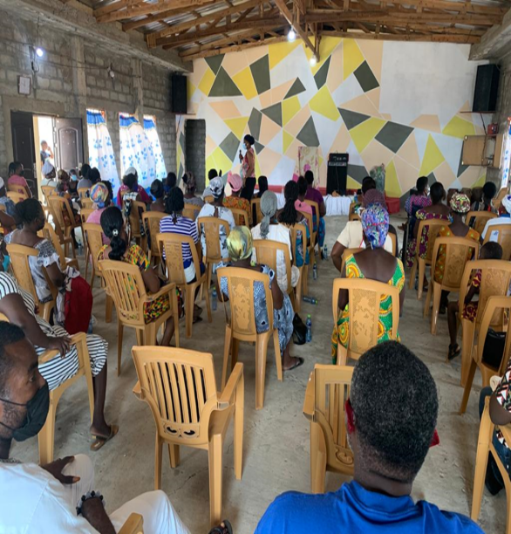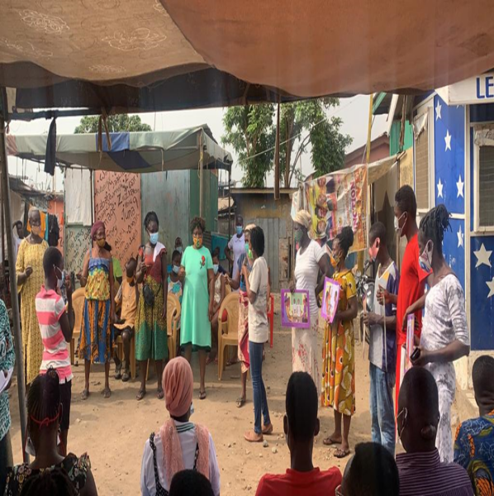
SENSITIZATION OF CAREGIVERS ON ABUSE MANAGEMENT
ENGAGEMENT WITH THE PUBLIC USING CHILD PROTECTION FLASH CARDS

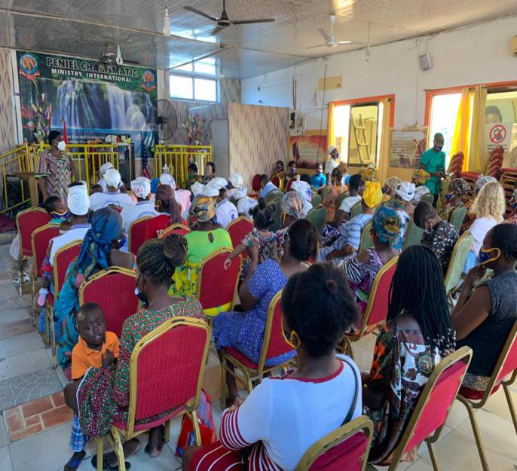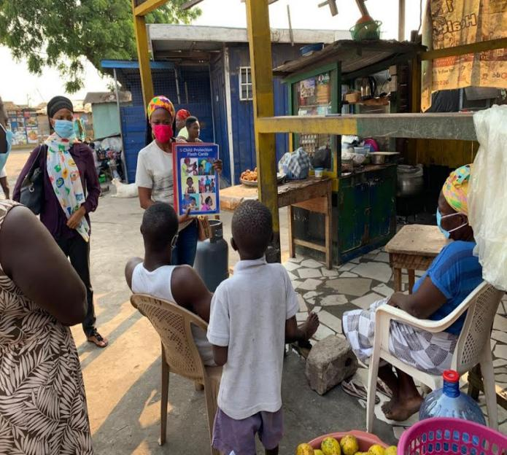
ILLUSTRATION ON CHILD PROTECTION AT HOME VISIT IN COMM 1

CHIEF INSPECTOR BLAY WITH PARTICIPANTS ON INTERNATIONAL WOMEN’S DAY CELEBRATION 2021

- PROGRAM DELIVERY NARRATIVE (SOCIAL WELFARE UNIT)
The Social Welfare unit undertook its activities through the three core programs of the Department. The three core programs are justice administration, child rights promotion and protection (family and child welfare) and community care.

- JUSTICE ADMINISTRATION
1.1 FAMILY TRIBUNAL
Social Welfare Officers serve as panel members on the T.D.C. and White House Family Tribunal Courts and assist the magistrates to make informed decisions on juveniles who find themselves in contact or conflict with the law.

Maintenance, family reconciliation, custody, access, defilement, juvenile, paternity and other cases were handled in the best interest of children. The total number of children involved are as follows; 21 males and 14 females.

The numbers of cases for the period under review are as follows;

NATURE OF CASES | OLD | NEW | TOTAL | SETTLED | PENDING | SINE DIE | STRUCK OUT | ABSENT
Maintenance | 13 | 14 | 27 | 5 | 22 | 0 | 0 | 0
Custody | 6 | 9 | 15 | 3 | 12 | 0 | 0 | 0
Access | 1 | 3 | 4 | 2 | 1 | 0 | 1 | 0
Paternity | 2 | 4 | 6 | 2 | 4 | 0 | 0 | 0
Unlawful Entry/Stealing (Juvenile/Young Offender) | 0 | 2 | 2 | 2 | 0 | 0 | 0 | 0
TOTAL | 22 | 32 | 54 | 14 | 39 | 0 | 1 | 0

1.2 SOCIAL ENQUIRY REPORTS (SERs)
During the period of January to March 2021, four (4) Social Enquiry Reports were ordered on young offenders by the Courts.
Thirteen (13) SERs were requested on custody cases. All reports were submitted and nine (9) recommendations of all reports were adopted by the court.

2.CHILD RIGHTS PROMOTION AND PROTECTION (FAMILY AND CHILD WELFARE)
2.1 STATUTORY WORK WITH FAMILIES AND CHILDREN
The following cases were handled to ensure the development and survival of children.
TYPE OF CASES | NEW CASES | TOTAL | SUCCESSFUL | PENDING | REF TO FT
Children maintenance | 21 | 21 | 18 | 2 | 1
Children custody | 5 | 5 | 3 | 2 | 0
Children access | 2 | 2 | 2 | 0 | 0
Paternity | 2 | 2 | 0 | 1 | 1
Family Welfare | 30 | 30 | 23 | 5 | 2

Children involved in the cases are 142 - 67 females and 75 males.
2.2.1 ASSISTANCE TO CHILDREN IN NEED OF CARE AND PROTECTION
There are two (2) residential homes for children (RHC) in Tema i.e SOS Children’s Villages and Remar Christian Rehabilitation Center. These homes provide temporal shelter for vulnerable children in need of care and protection. The metropolitan office during the quarter provided series of coaching sections for Remar in order for managers to be abreast and conversant with the case management SOPs and other laws and legislations regulating the operations of RHC.
During the quarter, eleven (11) vulnerable children were referred to the department. After processing the necessary documents, the children were placed at SOS Children’s Villages and Save Them Young Missions. Investigations were carried out and some of the children were reunified with their family as illustrated by the table as follows:
S/N | ADMISSION  DATE | NAME | AGE | SEX | RHC ADMITTED | REMARKS
1 | 12/01/2021 | EE Emmanuel  Amoabi | 10 yrs | M | Save Them Young | Emmanuel has been reunified with his family at Kasoa.
2. | 08/01/2021 | Henry Agyemang-Duah | 14 yrs | M | Save Them Young | Henry has been reunified with his family in Kumasi.
4. | 01/02/2021 | Esther  Glikpor | 12 yrs | F | Save Them Young | Esther has been reunified with family.
5. | 11/02/2021 | Abiba  Mohammed | 4 months | F | SOS  Childrens’  Villages | Still at RHC
6. | 12/02/2021 | Baby  Precious | week old | F | SOS  Childrens’  Villages | Still at RHC
7. | 23/02/2021 | Wunam | 2 yrs | F | SOS  Childrens’  Villages | Wunam has been reunified with mother.
8. | 24/02/2021 | Joshua  Neglo | 4 yrs | M | SOS  Childrens’  Villages | Still at RHC
9. | 09/03/2021 | Chioma  Onwuasoze | 16 yrs | F | Save  Them  Young | Still at RHC and investigations are underway
10. | 16/03/2021 | Hawa  Abdallah | 14 yrs | F | Save  Them  Young | Hawa has been reunified with her mother at Amasaman.

2.2.2 MONITORING OF RHC AND FOLLOW UP ON CASES
The metro office monitored four (4) RHC to ensure they comply with the standard operating procedures on case management and intersectoral standard operating procedures and other related laws and legislations. There was follow up on twenty (20) cases managed at the metro office. Funds for the exercise was provided by UNICEF through the Ministry of Local Government and Rural Development.

2.3 CHILD ABUSE CASE
An alleged sexual abuse case was reported to the department. A medical form was issued by DOVVSU for the victim to seek medical attention and issuance of medical examination report which was paid by the metropolitan office being part of UNICEF support to the MMDA for ISS. The amount paid was GHS 300.00. The results proved that the victim was sexually abused. The culprit has been arrested and perpetrator is currently being processed for court.
2.4 CHILD TRAFFICKING CASE
According to victim a gentleman in Nigeria promised 2 girls including victim that he had secured employment at a bar in Ghana for them. He met them at Port Harcourt and they travelled to Ghana, only to realize the promises were not real but rather they were to engage in prostitution. Alarmed they all run away from the woman. The police found them loitering at Community one centre and referred to the department.
She was sent to Save them young missions for temporal shelter for care and protection whilst investigations continue. She was interrogated but she could not provide her parents contact. However, she provided the contact of the agent who took them to Port Harcourt. The department collaborated with American Relief Corps and referred the case to Anti-human trafficking Unit of the Ghana Police Service for further investigations.
2.5 ADOPTION
Eight (8) clients who visited the office for enquiries on adoption procedures were advised and referred to the Regional office.
2.6.1 DAY CARE CENTRES
Monitoring exercises were conducted in twenty-seven (27) schools after reopening. Fourteen (14) schools submitted their expired certificates for renewing. Their premises were inspected to ascertain whether they met the standards of the department as enshrined in the Children’s Act 1998 (Act 560), the Children’s Amendment Act 2016 and the Child Rights Regulations 2002 LI 1705.

2.6.2 SCHOOLS INSPECTED
- Tema Happy Home
- Job School Complex
- First Step
- Mannaseh
- Gina Angels
- Cambridge
- Lilies of the Valley
- Brotherhood
- Leonardo
- Egyire
- Aldersgate
- St. Margaret
- Sunrise Marigold
- Evergreen
- Birth
- Hambert
- Sam Ashley
- Strong tower nanny care
- Golden child Montessori
- Believers Triumph Ministries
- Wonders International
- Mari Jay Academy
- Vido School Complex
- Mount zion
- Agnes daycare
- Presbyterian school
- Campresco

SCHOOLS NOT CONFORMING TO STANDARDS
- Birth
- Egyire
- Sam Ashley
- Golden Child Montessori
- Mount Zion
- Vido School Complex
- Wonders International
- Believers Triumph Ministries
- Strong Tower Nanny Care
SCHOOLS CERTIFICATE DUE FOR RENEWAL;
- Gina Angels
- Sunrise marigold
- First step
- Presbyterian
- Hambert
- Leonardo
- Lilies of the valley
- Mari Jay
- Aldersgate
- Evergreen
- Tema happy home
- Job school
- Manasseh
- Campresco
- COMMUNITY CARE
Community care seeks to promote access to social development services for the disadvantaged and excluded individuals and groups in society e.g. the aged, persons with disability, children, and women.
  - NON-PROFIT ORGANIZATIONS (NPOs)
NPOs are private non-governmental, non-profit organizations that complement the service delivery of the department. As part of the core programmes of the Department of Social Welfare and Community Development, Social Welfare Unit is to ensure that NPOs which operate in the country are duly registered and awarded certificates of recognition. The department further ensures that these certificates are renewed annually and routine monitoring is undertaken to make sure that the NPOs operate according to their spelt out aims and objectives, as well as laid down rules and regulations.

The following activities were undertaken during the quarter under review:

REGISTRATION
Three (3) organizations namely Next Generation Foundation, The Flamboyance Tree Foundation and Growth Aid applied for recognition as NPOs.

RENEWAL
Center for National Resources submitted their expired certificates and other necessary documents for renewal.

  - APPLICATION TO ACCESS 3% DACF
During the quarter, the department received applications from forty-five (45) PWDs requesting to access the DACF for medical, educational and livelihood support.

3.2.1 DISBURSEMENT OF FUNDS TO PWDs
During the same period 7 PWDs whose items were part of the fourth quarter 2020 disbursement were assisted to buy their requested items. These items include electronic products such as laptops and printers, industrial shoe sewing machine, electric hand saw and spraying machine. Some also benefited from market products such as tiger nuts, and bitter cola.
The table shows the name of beneficiaries and the items that were given to them.
S/N | NAME | AGE | SEX | TYPE OF DISABILITY | COMMUNITY/CONTACT | ITEMS ASSISTED TO BUY
1 | Naratu Yussif Abiba | 40 | F | Physically challenged | Community one 0542361599 | A bag of tiger nuts, half bag of bitter cola, and a bag of date.
2 | Elizabeth Dzanta | 32 | F | Physically challenged | Tema new Town  0556311039 | 15 packs of assorted soft drinks (fanta, cola, and cocktail) cartons of biscuits and children dresses for retail.
3 | Nene Opata | 54 | M | Physically challenged | Community four | Laptop, laptop bag and a mouse
4 | Moro Ibrahim | 28 | M | Visually impaired | Community one  0542065300 | Laptop, laptop bag, mouse and printer
5 | Fred Ghanney | 42 | M | Physically challenged | Community four  0540727144 | Items for manufacturing sound system amplifier- transistors, capacitors, and transformers
6 | Ampadu Patrick | 24 | M | Hearing impaired | Community one  0541284012 | Lap top and a printer
7 | Paul Asam Samuel | 46 | M | Physically challenged | Community 0244047244 | 3-in-1 printer

3.3 LIVELIHOOD EMPOWERMENT AGAINST POVERTY (LEAP) PROGRAMME
LEAP is a conditional and unconditional cash transfer programme for extreme poor households to cushion them against livelihood shocks. The eligibility criteria is the aged (65 years and above) without subsistence support, orphans and vulnerable children through their caregivers, persons with severe disabilities without productive capacity and pregnant women and or mothers with infants below one year. It is conditional on households to register children below 12 months with the birth’s registry, ensure children below 5 years periodically undergo growth monitoring and immunization, enrol and retain children of school going age in public schools, ensure children are not engaged in worst forms of child labour, national health insurance registration for LEAP household members.

LEAP promotes income security and social inclusion for poor households. Further with the introduction of the GhIPSS e-zwich payment system financial inclusion is promoted among the household caregivers.

489 households are on LEAP to access the bi-monthly cash transfers in Tema. The number of male caregivers are 108 and the number of female caregivers are 381. An amount of GHS 730.32 was received as operations and mobilization funds. The breakdown; community Focal Persons’ (CFPs) mobilization GHS 225.00; fuel GHS 37.50; sanitation GHS 200.00; supervision GHS 48.90; printing GHS 7.50, reporting and administration GHS 30.00.
Also, caregivers engaged in petty trading have invested part of their transfers into their businesses for profits.
During the quarter, caregivers received the 69th and 70th LEAP payment on behalf of households. The metro office urgently needs a computer with its accessories and a modem to promote effective communication with LEAP Management Secretariat (LMS) and other stakeholders. The office requests for a vehicle for effective monitoring of LEAP activities.
- CONCLUSION / RECOMMENDATIONS
In conclusion, the enumerated successes achieved during the quarter are largely attributable to the commitment of staff to promote social development. However, these challenges faced by the Metro office should be redressed for maximum output.
- Memoranda for request for funds for office use were not honoured. This greatly impeded effective and efficient service delivery. Memoranda should be honoured for office administration.
- Lack of means of transportation or T&T to undertake official visits/monitoring. Management should provide a vehicle to undertake official assignment and monitor activities within the metropolitan area.
- Staff Strength. Following the creation of Tema West from Tema Metro Assembly only eight (8) staff are left. There is the need to post professional staff to the Department to augment staff strength.
Notwithstanding, the aforementioned challenges officers executed their duties professionally with efficiency. It is important to emphasize and recommend that the challenges as stated should not be underestimated but addressed for effective and efficient service delivery.

COMPILED BY

EMELIA AKORFA MENOKPOR
HOD/PRINCIPAL SOCIAL DEVELOPMENT OFFICER

